# Individual Part

# SQL Statement (NP069472)

## DDL

Below are all the DDL commands which are used to create database for Tu university library. Which includes all the commands used to define the structure of database. The tables are created and altered using CREATE and ALTER Command.

Therefore, command is display below:

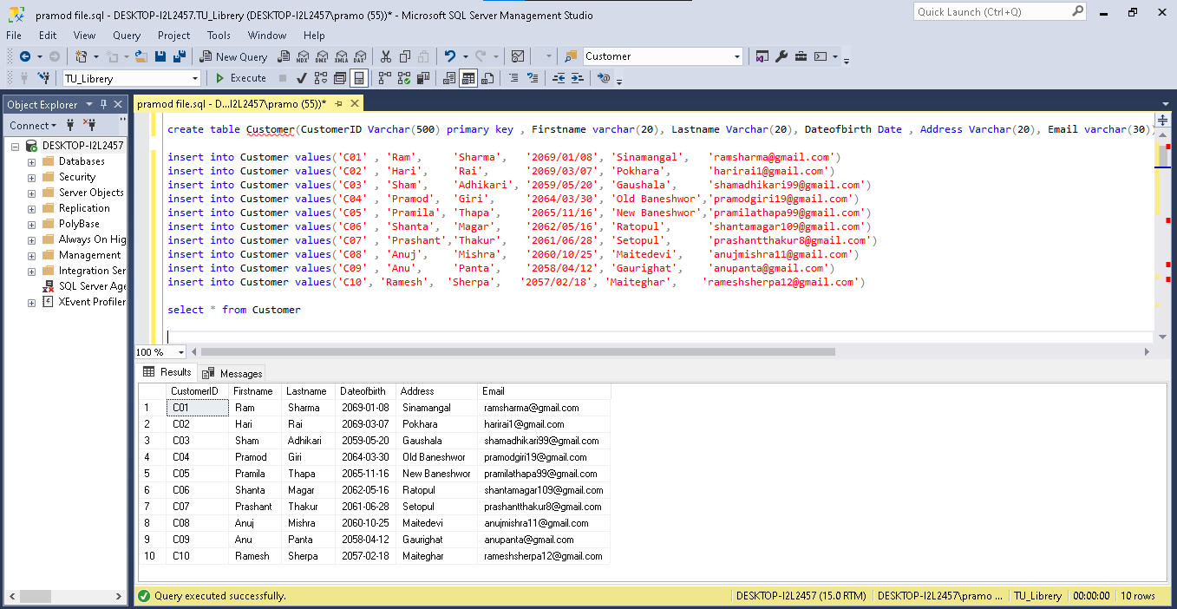

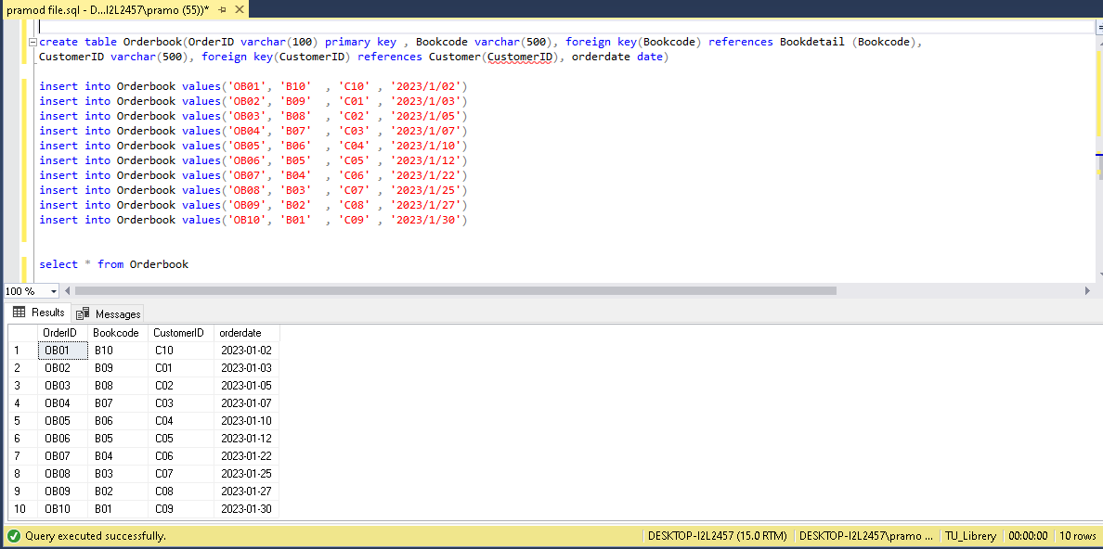

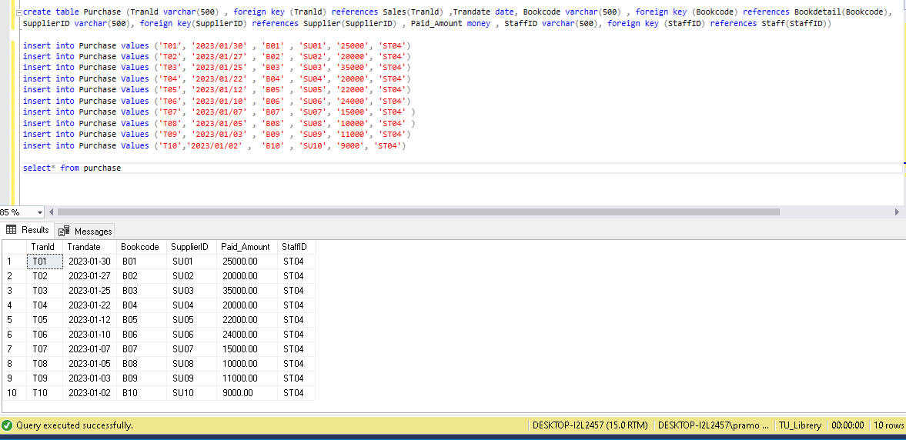

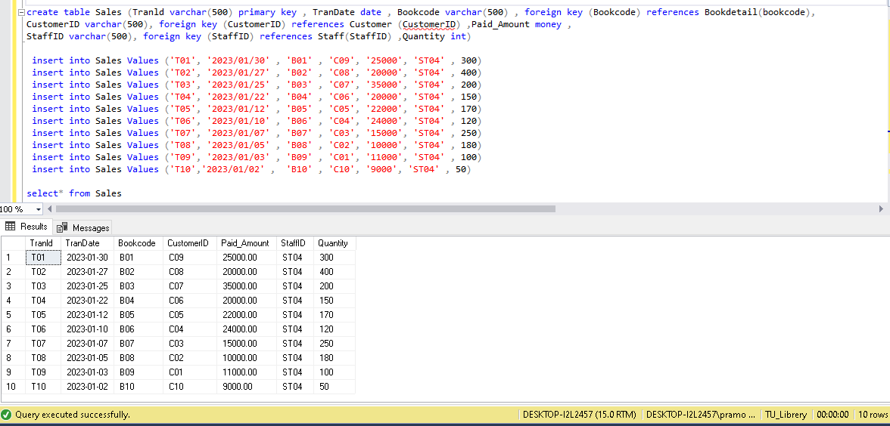

Select option:

## DML

Some of the queries answer also with there output are displayed below:

1. The query below display the latest book send by various publisher based on monthly basis.

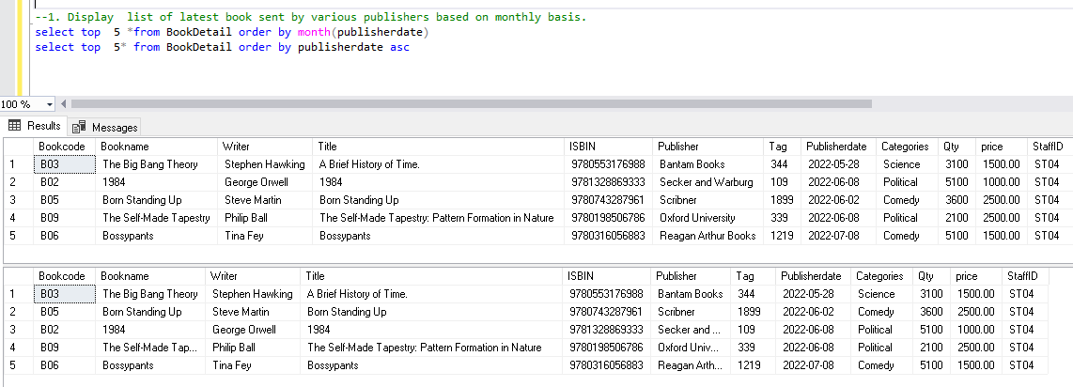

1. The below query display the list of book which was ordered by reception based on monthly basis

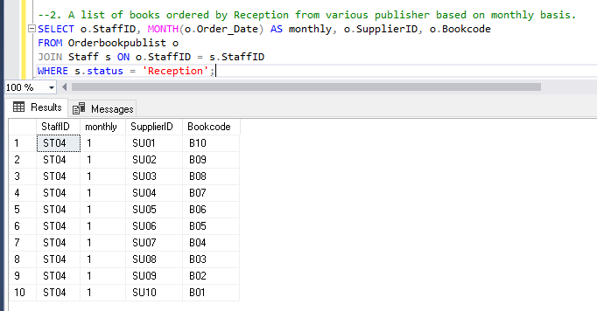

1. The below query display the invoice of various publisher. The invoice consist of invoice number, invoice date, publisher’s name and address and the total amount paid.

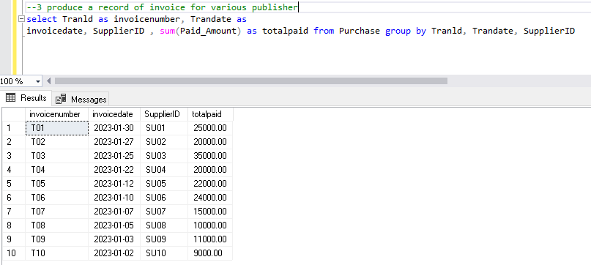

1. The below query display the list of all the customer who have register in the TUE Bookstore. The details they show about the customer are identification number , Firstname, Lastname and Address and contact number

1. The below query display the Book which have been delivered to the customer. They show the list of identification number, firstname, lastname, address and contact information.

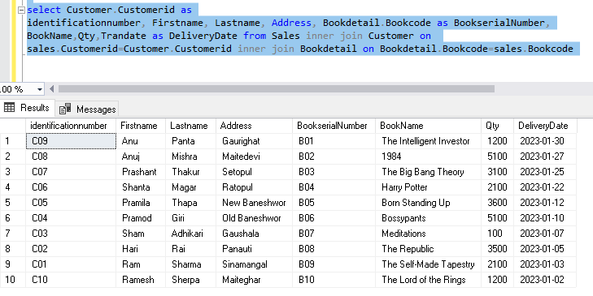

1. The below query show the book based on selected category

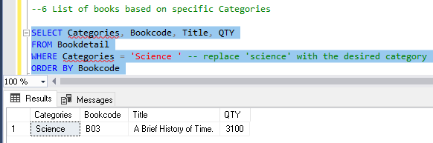

1. The below query show the list of total book for each category present in database of TU University

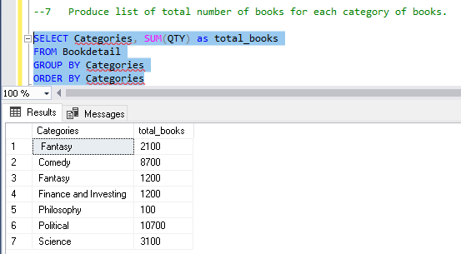

1. The below query show the list of total book and its total price as added by customer

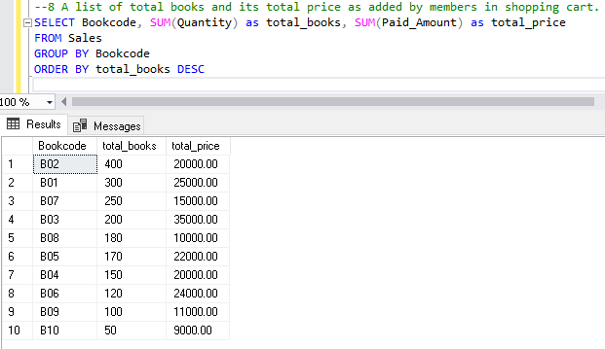

1. The below query show the list of book with various feedback and rating star.

Some of the other queries are:

Inserting in customer table:

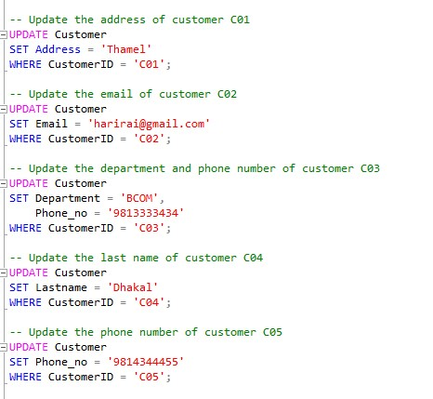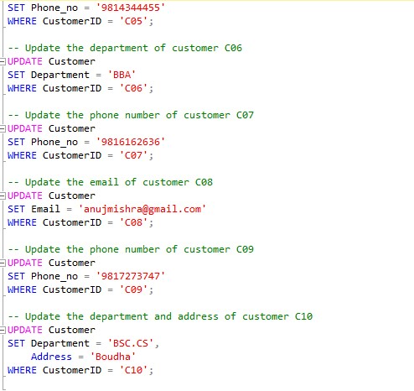

Here is the output: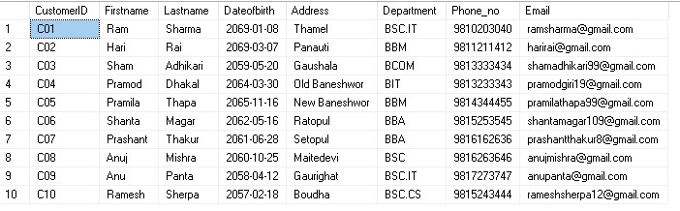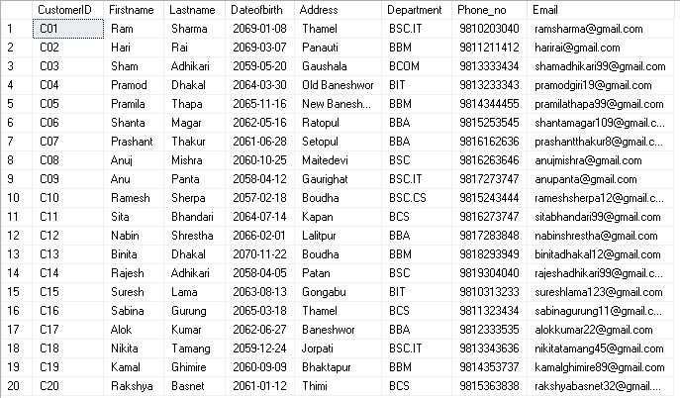

Retrieve rows with a wildcard: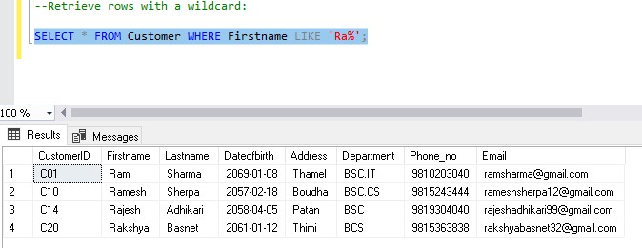

Retrieve rows sorted by a column: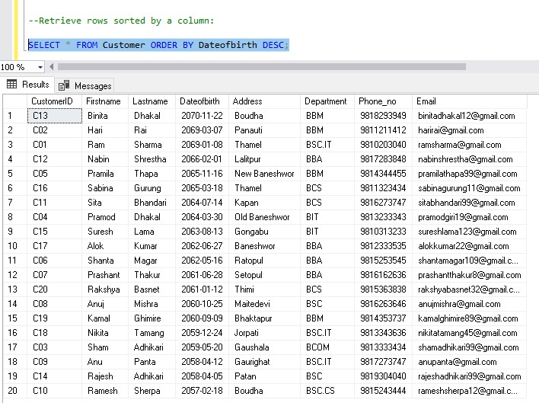

Updating all the Department in to “BSC”.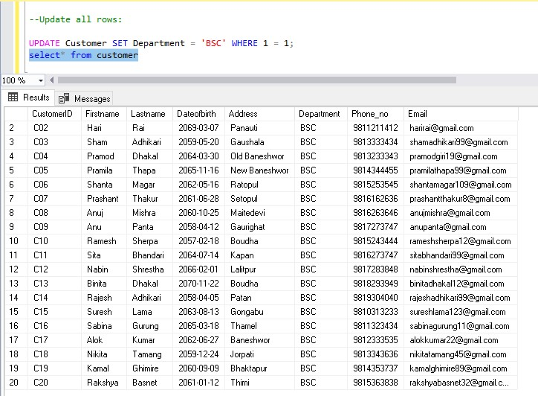

Updating all the customer department :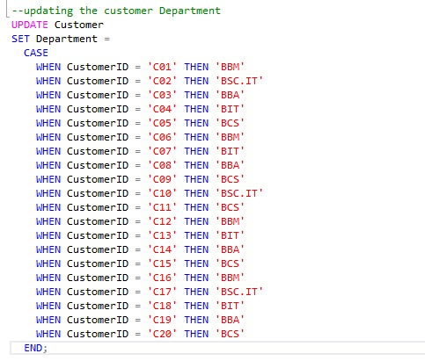

The output is :

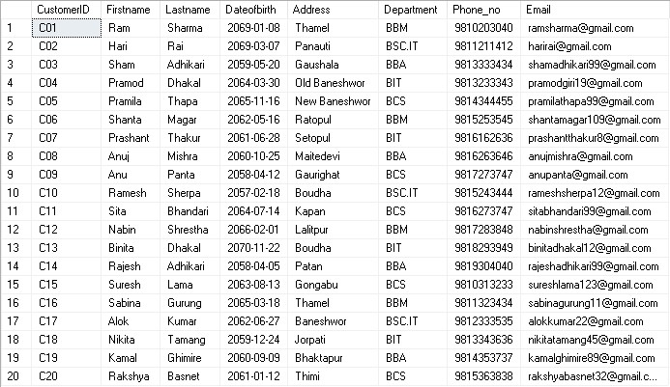

Retrieve rows with an inner join: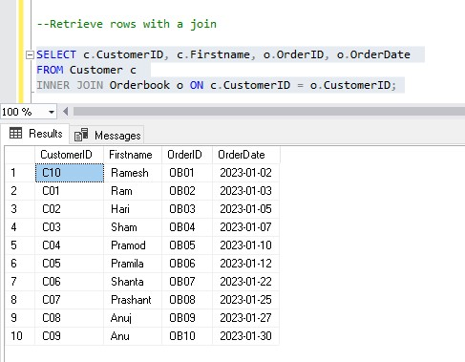

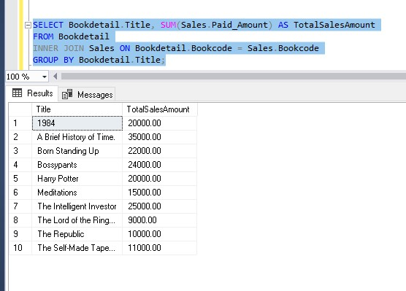

Retrieve rows with outer join:

